TOWN OFFICIALS

Julie W. Harris
Mayor

Justin Nelson
Zoning Administrator

Laurel S. Taylor
Town Clerk & FOIA Officer

Sands Anderson
Town Attorney

TOWN COUNCIL

Anthony Marchetti
Vice Mayor

Jackie Brown

Bonnie Schaschek

R. Wayne Nunnally

Judy Penniman

Dudley Patteson

Town of Irvington

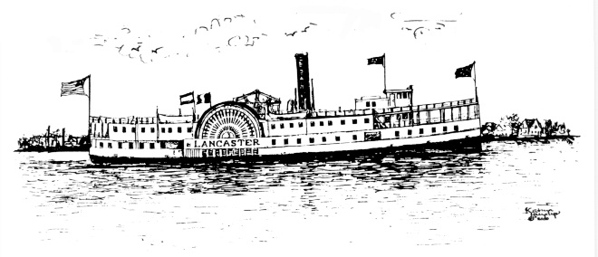

March 14, 2022

Dear Irvington Resident:

This letter addresses three topics for which there are forms on our website and/or available at the Town Office at 4203 Irvington Road, Irvington. The deadline for all of these (if applicable) will be June 1, 2022:

- Septic System Pump-Out/Inspection Form – This form documents that your septic system has either been inspected or pumped out and indicates if there is an effluent filter install in the outflow pipe from the septic tank and when it was installed. This must be done by homeowners every 5 years and be on file at the Town Office.

- Golf Cart registration – This form is on the website for easy download. Fill it in for the year 2022 and return it to the Town Office with your annual payment of $25. We now have 2022 stickers in orange which must be displayed on the front of your cart(s). You may come into the Town Office Monday through Friday from 9 a.m. to 1 p.m. to register and pick up your sticker.

- Short Term Rental Registration form AND the Occupancy Tax monthly forms – also available on the website, or at the Town Office. The registration form tells us what local Irvington address is being rented by the property owner and tells us what platform(s) are used to advertise the rental. Your mailing address, if different than the rental property, and your contact information is also on this form. At this time, there is no fee associated with the REGISTRATION form, but this is likely to change by June of this year. Once your rental(s) are registered, you also need to use the Occupancy Tax Form to remit a 4% tax to the Town of Irvington monthly. If your property is not rented for a month, no Occupancy Tax form needs to be sent into the Town Office.

To recap, forms are on our website at www.town.irvington.va.us. Go to the heading “Town Government” and choose the menu option “Forms.” All forms are downloadable, or simple visit the Town Office any weekday from 9 a.m. to 1 p.m. and pick up appropriate forms. Deadline for applicable forms is June 1, 2022.

Thank you for your attention to these matters,

Laurel S. Taylor
Town Clerk, FOIA Officer and Notary Public

