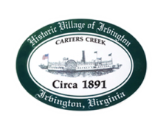
Town of Irvington Zoning Administrator Report
Prepared for Planning Commission & Town Council
Prepared For: December PC & TC Meetings
Staff Contact: Justin Nelson, Zoning Administrator

Zoning Permits:

#2022-21 new deck on Cedardale Lane

Miscellaneous:
new signage application for the gas station; site visit to view renovations at Crockett’s Landing; site visit to newly renovated house on Steamboat Lane
New CUP application for yoga/pilates studio for 301 Steamboat

STR Report: 22 were grandfathered, 1 sold thus removed from the list, leaving 21; we now have 10 applications in, two for January’s meetings.

ZA will be out of the office from January 13th through February 3rd

.

