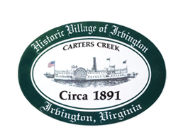

THE TOWN OF IRVINGTON
PLANNING COMMISSION REGULAR CALLED MEETING
IRVINGTON TOWN OFFICE, 4203 IRVINGTON RD., IRVINGTON, VA
TUESDAY, February 1, 2022; 6:30PM

- Call to order – Tom Chapman, Vice Chair

- Roll Call and Determination of Quorum- T. Chapman, Vice Chair

3. Approve Minutes
- January 4, 2022

- Report from Vice Chair – Tom Chapman

- Election of Officers
  - Chairmen
  - VC
  - Other as needed

- Report from Zoning Administrator – Justin Nelson

- Old Business
- Status Report on Town Survey- Brian Forrester
- Discuss Designated Outdoor Refreshment Area Status – A. Pollard

- New Business
- Camp Irvington CUP- Justin Nelson
- Discuss guidelines for CUPs/CUPs in RPA and other CUP procedures- J. Nelson

- Next meeting
- March 1, 2022, at the Town Office
9. Adjourn

