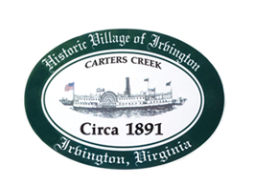

THE TOWN OF IRVINGTON
JOINT TOWN COUNCIL & PLANNING COMMMISSION PUBLIC HEARING

IRVINGTON BAPTIST CHURCH, IRVINGTON, VA
TUESDAY, September 6, 2022; 5:30PM

Preliminary Agenda

- Call to order – Mayor Harris

- Roll Call of Planning Commission

- Roll Call of Town Council

- Approval of agenda

- Tides Inn CUP

-Presentation by Tides Inn Representatives
-Public Comment on CUP

- Short Term Rental Ordinance – Presentation
- Public Comment on Ordinance

- Adjournment

