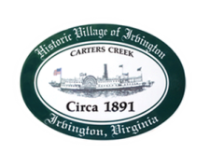
Town of Irvington Zoning Administrator Report
Prepared for Planning Commission
Prepared For: June 7th, 2022
Staff Contact: Justin Nelson, Zoning Administrator

Zoning Permits

2022-6: dead tree within RPA removal on Old Mill Cove
2022-7: sign for Refuel
2022-8: addition on home at James Point Road
2022-9: dock rebuild on Chases Cove

Miscellaneous

Completed DEQ second phase of audit on May 24th, DEQ is pleased with Town Staff, especially L Taylor’s work on septic letters; third phase will be site visits to previously approved CUP within the RPA. Have received two engineering quotations for expansion of the sidewalks; two site visits for overgrown lawns, both have been mowed. Communicated with architects for new homes proposed for Steamboat Road, no plans or permits filed as of this date.
.

.

