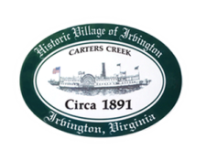
Town of Irvington Zoning Administrator Report
Prepared for Town Council
Prepared For: July 14, 2022
Staff Contact: Justin Nelson, Zoning Administrator

Zoning Permits

2022-10: garage 932 King Carter

Miscellaneous

Site visit to Fisher’s Pitt w/MME personnel, Mr Fisher will begin on removing the tires; site visit to King Carter derelict home to see if any office files therein, none were found; site visit to Sam’s Cove for overgrown bamboo; site visit to 932 King Carter for garage inspection; site visit to Lee Ln for landscaping in RPA, less than 2500 square feet.
Final phase of DEQ audit is July 8th to include a visit to Fisher’s Pit, Stephens pool, Tides Inn shoreline project.

.

