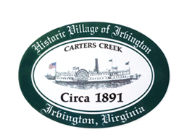

THE TOWN OF IRVINGTON
PLANNING COMMISSION WORKSHOP
IRVINGTON TOWN OFFICE
MONDAY, NOVEMBER 15, 2021; 5:30PM

- Call to Order - Julie Harris, Chair

- Roll Call - Julie Harris, Chair

- Approve Agenda

- Review updated submissions for companies developing Town Survey, revision of Comprehensive Plan & Zoning Code Update
- The Berkley Group, LLC
- EPR-PC
- Discussion / vote

- Adjourn

