TOWN OFFICIALS

Julie W. Harris
Mayor

Justin Nelson
Zoning Administrator

Laurel S. Taylor
Town Clerk
FOIA Officer

Sands Anderson
Town Attorney

TOWN COUNCIL

Bonnie Schaschek
Vice Mayor

Jackie Brown

R. Wayne Nunnally

Judy Penniman

Dudley Patteson

Gabe del Rio

Town of Irvington

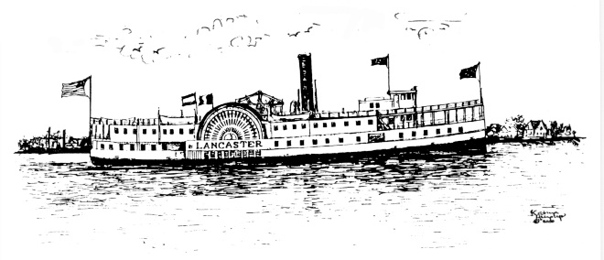

September 27th, 2022

Town Council

The Zoning Administrator proposes the following change to 194.195, B, (5) of the Town Sign Ordinance:

Remove: The design is to be approved by the Town Council

Insert: The design, if in compliance with 154.197, shall be approved by the Zoning Administrator

