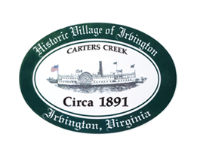

THE TOWN OF IRVINGTON
PLANNING COMMISSION PUBLIC MEETING ON RESULTS OF TOWN SURVEY

IRVINGTON BAPTIST CHURCH, 53 King Carter Dr., IRVINGTON, VA
Thursday, Nov 10, 2022; 5:30PM

Agenda

- Call to order – Tom Chapman

- Roll Call - T. Chapman

- Overview of Survey and Steps to update Comprehensive Plan

- Public Comment on Survey Results- limit of 3 minutes per person

Please base comments on your review of the survey results. The survey results are available on the Town website under “Planning Commission” or with the meeting agenda.

- Adjourn

